COVID-19 INFORMATIONAL POSTERS
Consider posting these informational materials in highly visible areas such as the weight room, gyms, locker rooms, field houses, hallways, and staff offices.

FACTS
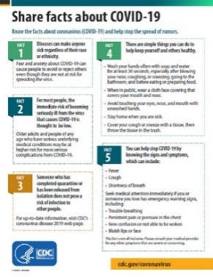 | “Share facts about COVID-19” - CDC  https://www.cdc.gov/coronavirus/2019-ncov/about/share-facts-h.pdf  *Available in 22 additional languages
SYMPTOMS
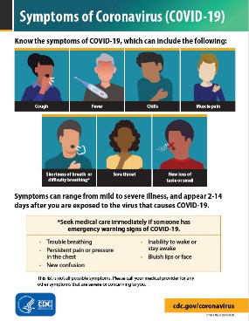 | “Symptoms of Coronavirus (COVID-19)” - CDC  https://www.cdc.gov/coronavirus/2019-ncov/downloads/COVID19-symptoms.pdf  *Available in 22 additional languages  **Available in poster size (11” W x 17” H)
FACEMASKS
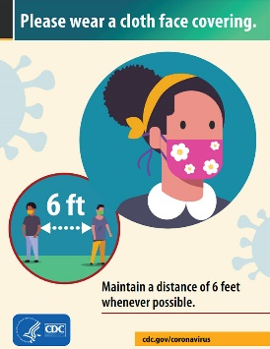 | “Please wear a cloth face covering.” - CDC  https://www.cdc.gov/coronavirus/2019-ncov/downloads/cloth-face-covering-building-entrance.pdf  *Available in 22 additional languages
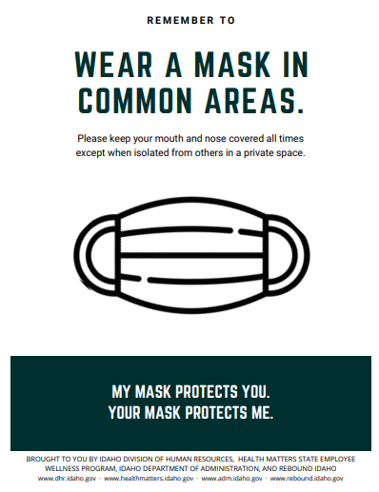 | “Wear a mask in common areas” – ID GOV  https://healthmatters.idaho.gov/05_covid_wear-mask-2/
FACEMASKS (Cont.)
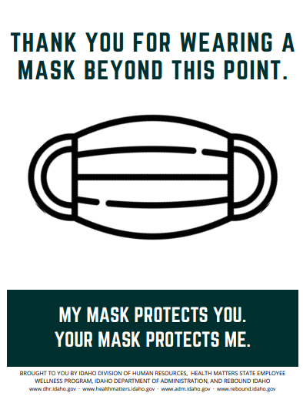 | “Thank you for wearing a mask beyond this point” – ID GOV  https://healthmatters.idaho.gov/05_covid_thank-you-mask-2/
PROTECTING YOURSELF AND OTHERS
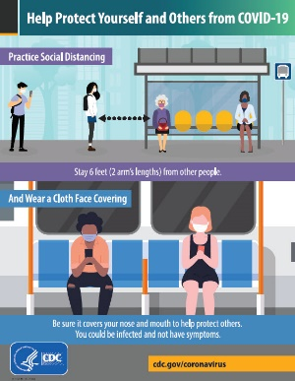 | “Help Protect Yourself and Others from COVID-19” – CDC  https://www.cdc.gov/coronavirus/2019-ncov/downloads/COVID19-social-distancing-cloth-face-coverings.pdf  *Available in Spanish  **Available in poster size (17” W x 24” H)
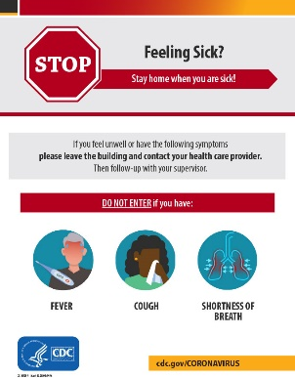 | “Feeling Sick?” - CDC  https://www.cdc.gov/coronavirus/2019-ncov/downloads/StayHomeFromWork.pdf  *Available in Spanish
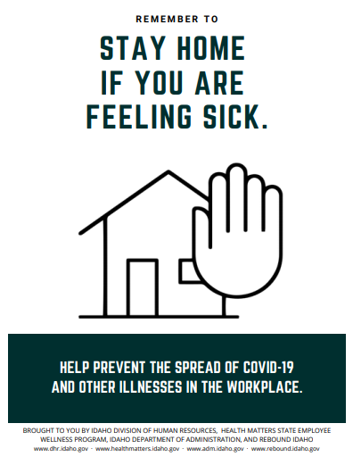 | “Stay home if you are feeling sick” – ID GOV  https://healthmatters.idaho.gov/08_covid_stay-home-2/
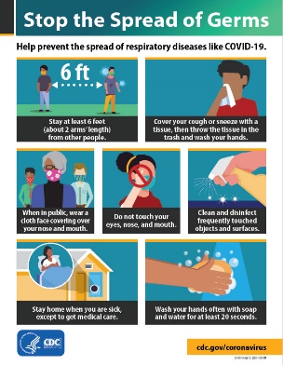 | “Stop the Spread of Germs” - CDC  https://www.cdc.gov/coronavirus/2019-ncov/downloads/stop-the-spread-of-germs.pdf  *Available in 22 additional languages
PROTECTING YOURSELF AND OTHERS (Cont.)
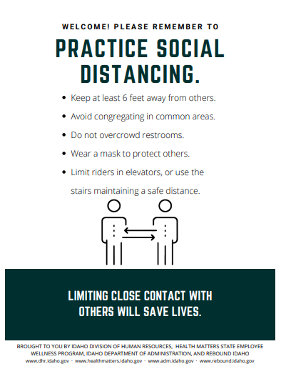 | “Practice social distancing” – ID GOV  https://healthmatters.idaho.gov/02_covid_social-distance_entrances-2/
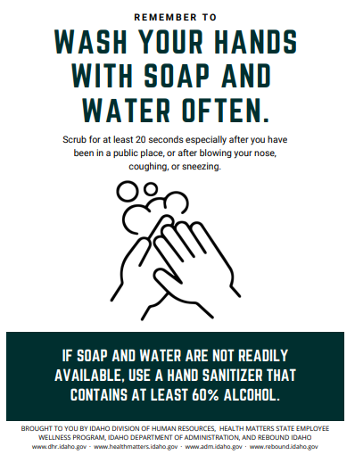 | “Wash your hands” – ID GOV  https://healthmatters.idaho.gov/03_covid_wash-hands-2/
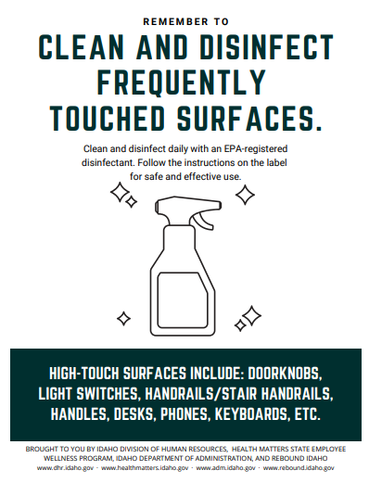 | “Clean and disinfect frequently touched surfaces” – ID GOV  https://healthmatters.idaho.gov/04_covid_clean-disinfect-2/
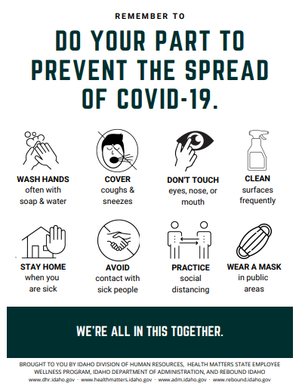 | “Do your part to prevent the spread of COVID-19” – ID GOV  https://healthmatters.idaho.gov/09_covid_tips-2/
COVID-19 INFORMATIONAL HANDOUTS
Consider providing these handouts to student-athletes and staff prior to the start of the season and as necessary. Some handouts allow for editing to your specific institutional and regional guidelines.

FACTS
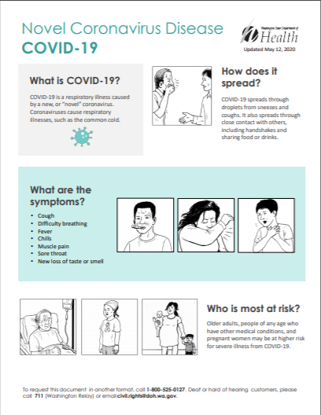 | “Novel Coronavirus Disease COVID – 19” – WA DOH  https://www.doh.wa.gov/Portals/1/Documents/1600/coronavirus/COVID-19-Factsheet-English.pdf  *Available in 6 additional languages
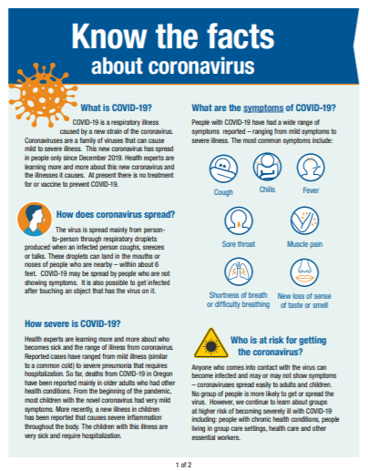 | “Know the facts about coronavirus” – OR GOV  https://sharedsystems.dhsoha.state.or.us/DHSForms/Served/le2356.pdf
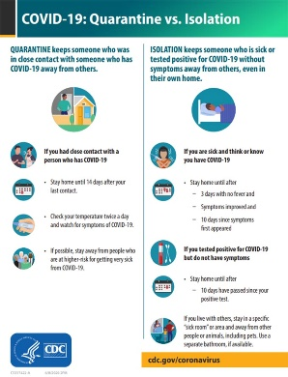 | “COVID-19: Quarantine vs. Isolation” - CDC  https://www.cdc.gov/coronavirus/2019-ncov/downloads/COVID-19-Quarantine-vs-Isolation.pdf
FACE MASKS
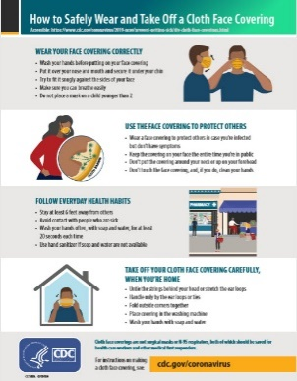 | “How to Safely Wear and Take Off a Cloth Face Covering” - CDC  https://www.cdc.gov/coronavirus/2019-ncov/downloads/cloth-face-covering.pdf  *Available in 22 additional languages
PROTECTING YOURSELF AND OTHERS
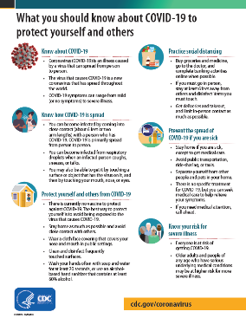 | “What you should know about COVID-19 to protect yourself and others” - CDC  https://www.cdc.gov/coronavirus/2019-ncov/downloads/2019-ncov-factsheet.pdf  *Available in 22 additional languages
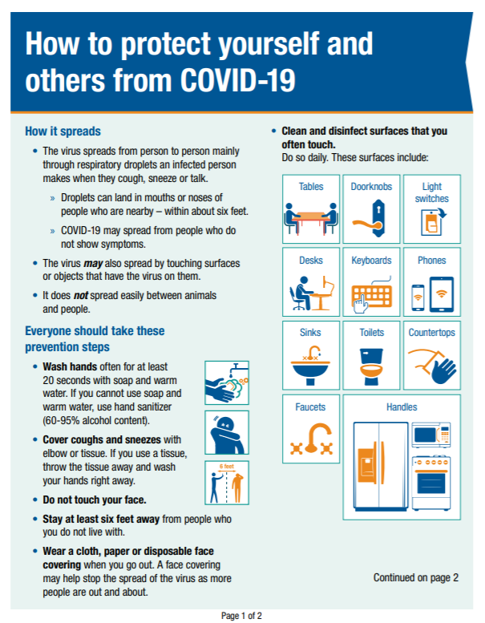 | “How to protect yourself and others from COVID-19” – OR GOV  https://sharedsystems.dhsoha.state.or.us/DHSForms/Served//LE2681.pdf  *Available in 9 additional languages
IN THE PRESENCE OF A SUSPECTED OR POSTIVE CASE OF CORONAVIRUS
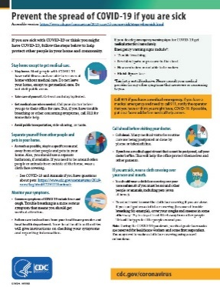 | “What to do if you are sick” – CDC  https://www.cdc.gov/coronavirus/2019-ncov/downloads/sick-with-2019-nCoV-fact-sheet.pdf  *Available in 25 additional languages
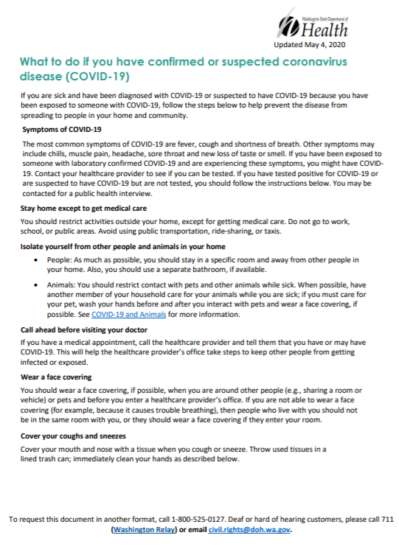 | “What to do if you have confirmed or suspected coronavirus disease (COVID-19)” – WA DOH  https://www.doh.wa.gov/Portals/1/Documents/1600/coronavirus/COVIDcasepositive.pdf  *Available in 27 additional languages
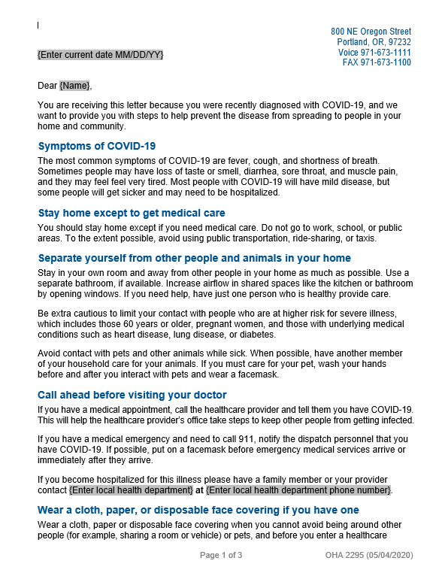 | Information letter for someone diagnosed with COVID-19 – OR GOV  https://sharedsystems.dhsoha.state.or.us/DHSForms/Served/le2295.docx  *Editable Word document
IN THE PRESENCE OF A SUSPECTED OR POSTIVE CASE OF CORONAVIRUS (Cont.)
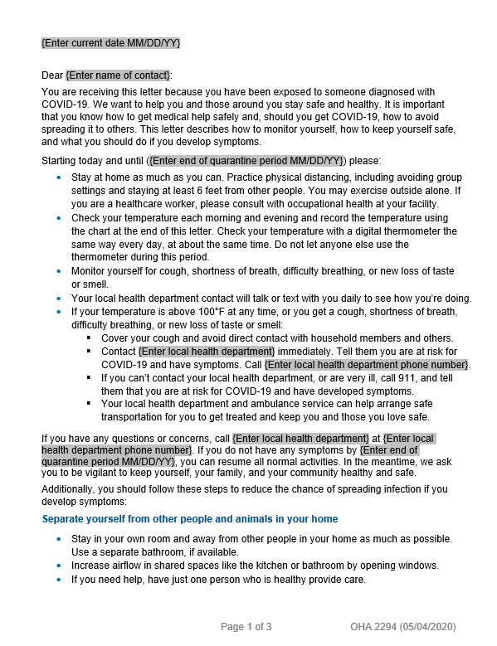 | Information letter for someone who has had contact with an individual with COVID-19 – OR GOV  https://sharedsystems.dhsoha.state.or.us/DHSForms/Served/le2294.docx  *Editable Word document; includes a table for daily symptom checks.
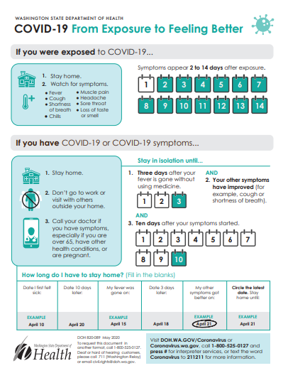 | “COVID-19 from Exposure to Feeling Better” – WA DOH  https://www.doh.wa.gov/Portals/1/Documents/1600/coronavirus/COVID-19-ExposureFeelingBetter.pdf  *Available in 16 additional languages
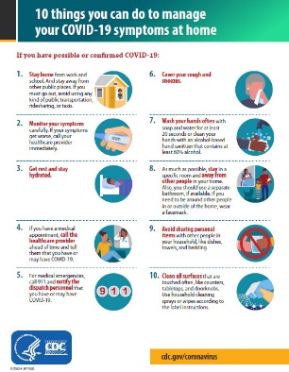 | “10 things you can do to manage your COVID-19 symptoms at home” - CDC  https://www.cdc.gov/coronavirus/2019-ncov/downloads/10Things.pdf  *Available in 22 additional languages

